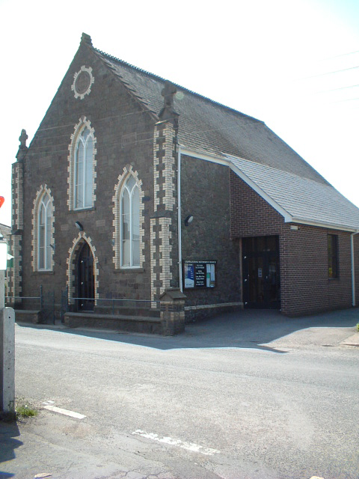Morchard Bishop Methodist Church
Fore Street, Morchard Bishop. EX17 6NX

HEALTH AND SAFETY AT WORK POLICY FOR MORCHARD BISHOP METHODIST CHURCH

This statement is issued in conformity with Section 2(3) of the Health and Safety at Work Act 1974 as a statement of the general policy of the Morchard Bishop Methodist Church with respect to the health and safety at work of the employees of Morchard Bishop Methodist Church and of others.

- Statutory Duty of the Morchard Bishop Methodist Church

Morchard Bishop Methodist Church has a duty to ensure so far as is reasonably practicable, the health, safety and welfare at work of its employees and, in particular to:

1.1 Provide and maintain equipment and systems of work that are safe and without risks to health;
1.2 Arrange for ensuring safety and absence of risks to health in connection with the use, handling, storage and transport of articles and substances;
1.3 Provide such information, instruction, training and supervision as is necessary to ensure the health and safety at work of the employee;
1.4 Maintain any place of work under the Morchard Bishop Methodist Church's control in a condition that is safe and without risk to health and provide and maintain means of access to and egress from it that are safe and without risk;
1.5 Provide and maintain a working environment for the employees that is safe, without risk to health, and adequate as regards facilities and arrangements for their welfare at work.

- Statutory Duty of the Employees/Volunteer

Every employee/volunteer has, while at work, the duty to:

2.1 Take reasonable care for the health and safety of himself or herself and of other persons who may be affected by his or her acts or omissions at work;
2.2 Co-operate with Morchard Bishop Methodist Church so far as is necessary to enable any duty or requirement imposed on Morchard Bishop Methodist Church or upon any other person by or under any relevant statutory provision to be performed or complied with.

- Policy Statement

It is the policy of Morchard Bishop Methodist Church to promote the health and safety at work of the staff and of all visitors to the premises of Morchard Bishop Methodist Church and to that intent to:

3.1 Take all reasonably practicable steps to safeguard the health, safety and welfare of the staff and of visitors to Morchard Bishop Methodist Church's premises.
3.2 Provide adequate working conditions for employees with proper facilities to safeguard their health and safety and to ensure that any work which is undertaken produces no unnecessary risk to health or safety.
3.3 Encourage employees to co-operate with Morchard Bishop Methodist Church in all safety matters in the identification of hazards which may exist and in the reporting of any condition which may appear dangerous or unsatisfactory.
3.4 Encourage each employee/volunteer to accept his or her own responsibility not to endanger himself or herself or others and actively to assist in fulfilling the requirements and spirit of the legislation.

- Health and Safety Rules

All employees/volunteers must exercise ordinary care to avoid accidents in their activities at work and comply with the following general rules and any specific rules which Morchard Bishop Methodist Church may publish from time to time.

- Accident Book

Any injury suffered by an employee/volunteer in the course of his or her employment, however slight, must be recorded together with such other particulars as are a requirement by statutory regulations in the accident book maintained by Morchard Bishop Methodist Church. The Incident form should be completed and returned to the Church Safeguarding officer and Minister. A copy should be kept in the Office.Minor First Aid incidences should be recorded in the Accident book.

- Fire Procedures

All employees/volunteers must familiarise themselves with fire escape routes and procedures and follow the directions of the Morchard Bishop Methodist Church in relation to fire.

- Equipment and Appliances

No equipment or appliance may be used other than as provided by or specifically authorised by or on behalf of Morchard Bishop Methodist Church and any directions for the use of such must be followed precisely.

- Safety Clearways

Corridors and doorways must be kept free of obstructions and properly lit.

- Working at Heights

No employee/volunteer of the Church may undertake work above six feet from floor level, [or ground level if working outside], without having been fully trained in the use of any equipment needed to reach the working area required. If you are required to use a ladder, and the work you are required to do necessitates your being at a height where your feet are more than six feet above ground level, this work should only be carried out with a colleague aiding and assisting you. As a general rule, any work required to the outside of the buildings should be undertaken by properly qualified and equipped outside contractors who will have the full range of equipment needed.

- Maintenance

Defective equipment, furniture and structures must be reported as such without delay.

- Hygiene and Waste Disposal

Facilities for the disposal of waste materials must be kept in a clean and hygienic condition. Waste must be disposed of in an appropriate manner and in accordance with any special instructions relating to the material concerned.

- Drink and Drugs

The use of intoxicants at your place of work is forbidden. No employee/volunteer may undertake his or her duties if under the influence of drink or drugs, except in the case of drugs when he or she is under medical supervision.

This policy was agreed at Church Council on 11th October 2016
Signed (Rev John Wiltshire)
Review Date: 11th October 2017

